PMG201c - Final PE #2 (Fall 2024)
Request 1 (20%): provide project name and give detailed descriptions for the project in which you mention clearly its key characteristics: purpose/objectives (unique), customer/sponsor (clearly defined), success criteria, and other project constraints (cost, resources, or quality)
Request 2 (20%): what type of organization you think the project using and what type of organization you think that should apply or should have applied along with the reasons for this? Provide relevant reasons for your answers
Request 3 (20%): identify at least 3 significant risks that you think the project faces. For each risk determine how likely you think it is to occur (the probability) and the impact if it does occur. Create your own scoring system for probability and impact. You might use High-Medium-Low; you might use numeric values or you might use percentages. Define a response for each of these risks.
Request 4 (20%): You have defined and estimate project schedule with below activities
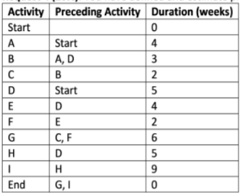
You are requested to do the critical path analysis to
Provide all the paths (from the start to the end of the project) with duration for each.
Specify at least 3 solutions (with detailed explanation) to shorten this schedule 3 weeks.
Request 5 (20%): Assuming that your project was reported with the following status:
- AC = $120,000;
- PV = $125,000;
- CV = -10,000.
Calculate and give your comments (current status, forecast and recommended adjustment) on the schedule and cost performance of the project

